**NATIONAL SCIENCE**

* **ENGINEER’S**
* Engineers, as practitioners of engineering, are professionals who invent, design, analyze, build and test machines, complex systems, structures, gadgets and materials to fulfill functional objectives and requirements while considering the limitations imposed by practicality, regulation, safety and cost. The word engineer (Latin ingeniator, the origin of the Ir. in the title of engineer in countries like Belgium and The Netherlands) is derived from the Latin words ingeniare ("to contrive, devise") and ingenium ("cleverness").The foundational qualifications of a licensed professional engineer typically include a four-year bachelor's degree in an engineering discipline, or in some jurisdictions, a master's degree in an engineering discipline plus four to six years of peer-reviewed professional practice (culminating in a project report or thesis) and passage of engineering board examinations.
* **TYPES OF ENGINEER’S**
* ***Automobile engineering***
* ***Aerospace engineering***
* ***Agricultural engineering***
* ***Architectural engineering and building engineering***
* ***Biomedical engineering***
* ***Chemical engineering***
* ***Civil engineering***
* ***Mining engineering***
* ***Electrical engineering***
* ***Industrial engineering***
* ***Electrical engineering***
* 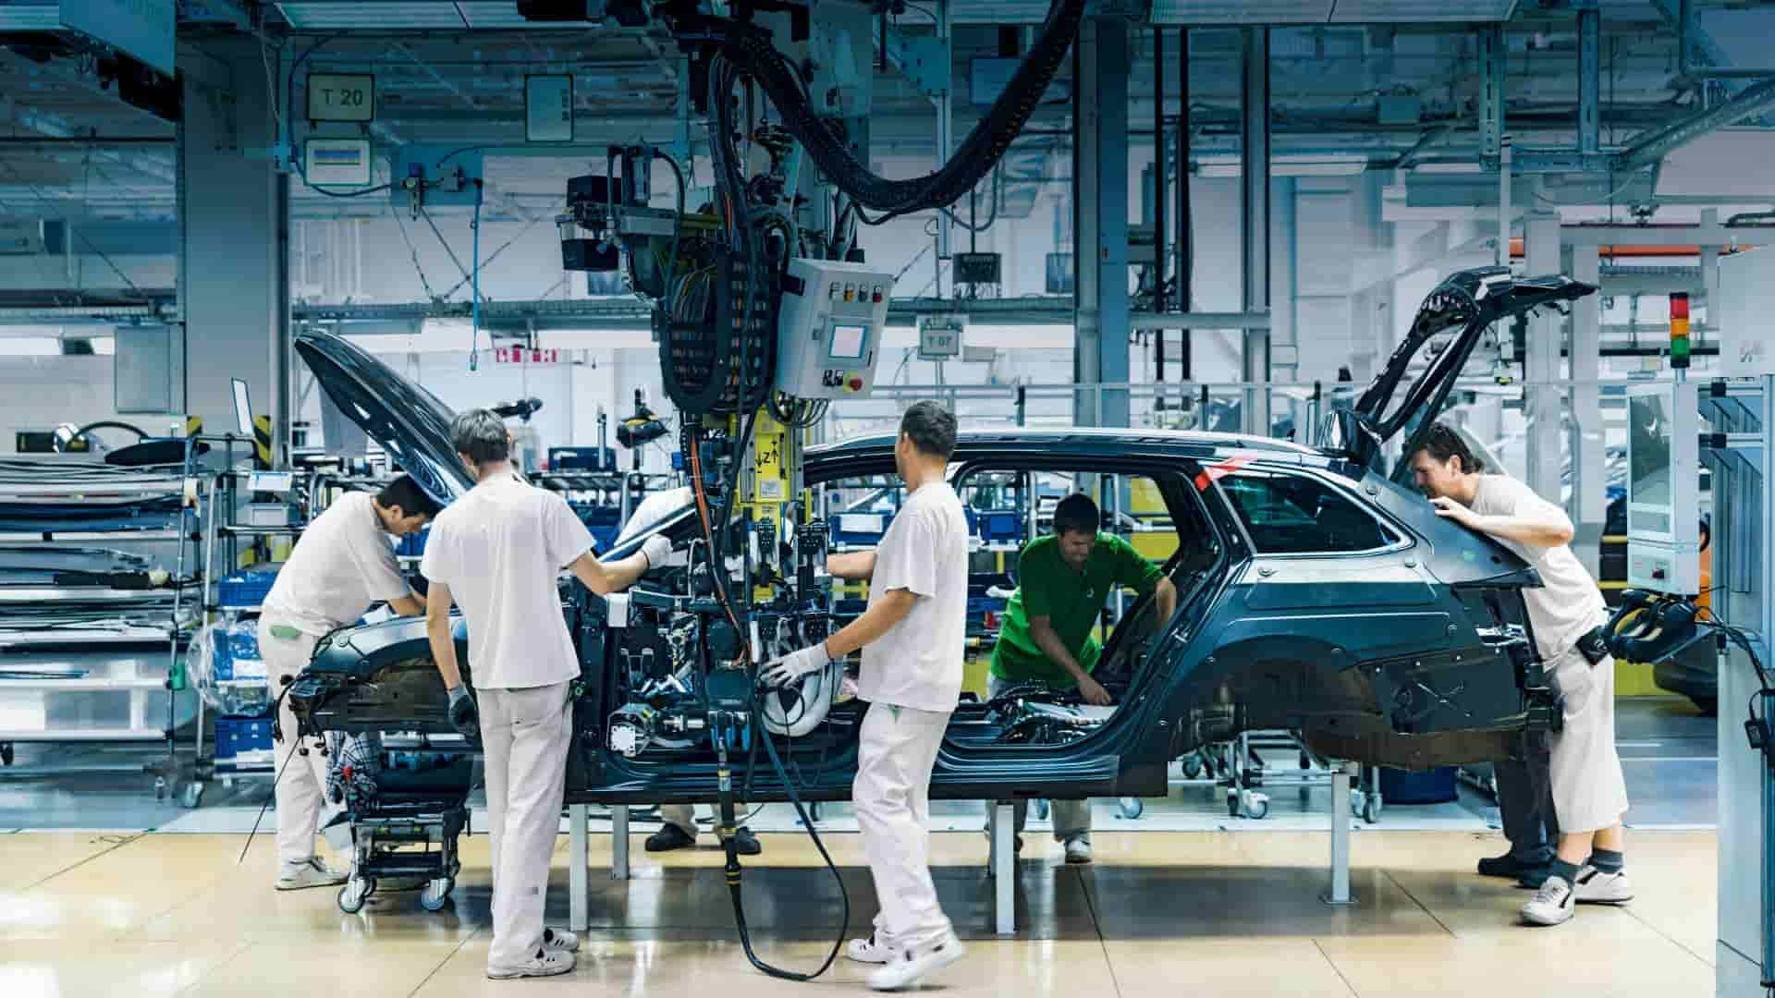**Automobile Engineering=** Focuses on the development of automobiles and related technology.
* 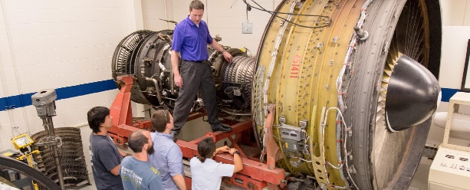**Aerospace Engineering=** Focuses on the development of aircraft and spacecraft.

* 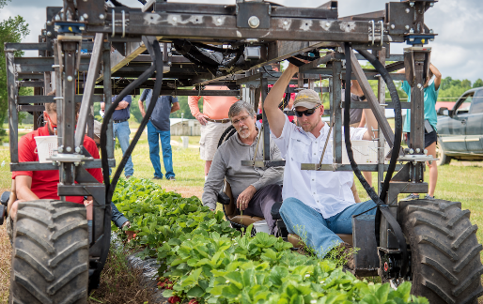**Agricultural Engineering=** Focuses on the engineering, science, and Technology for the production and processing of food from agriculture.
* 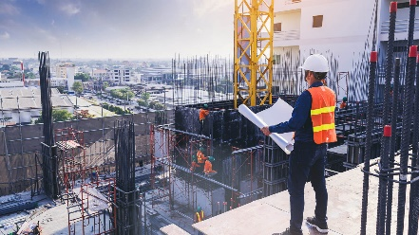**Architectural engineering and building engineering=** Focuses on building and construction.
* **Biomedical engineering=** Focuses on closing the gap between engineering and medicine to advance various health care treatments.
* **Chemical engineering=** Focuses on the manufacturing of chemicals and/or extraction of chemical species from natural resources.
* **Civil engineering=** Focuses on the construction of large systems, structures, and environmental systems.
* 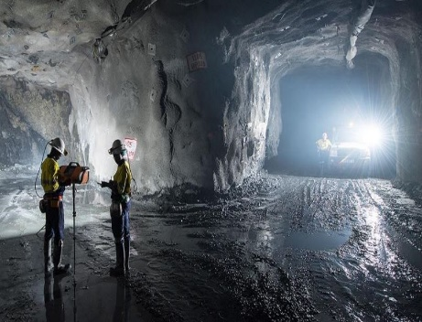**Mining engineering=** Focuses on the use of applied science and technology to extract various minerals from the earth, not to be confused with metallurgical engineering, which deals with mineral processing of various ores after they have already been mined**.**
* 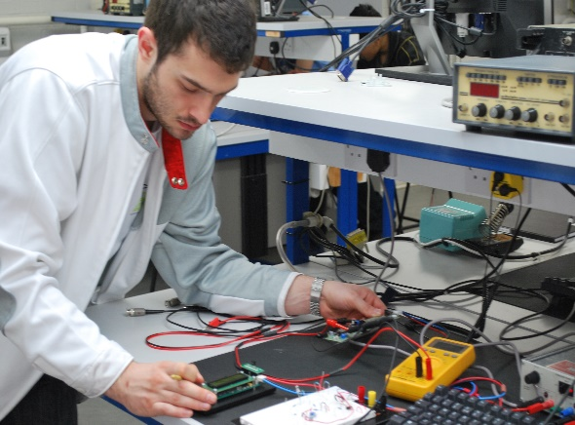**Electrical engineering=** Focuses on application of electricity, electronics, and electromagnetism**.**